***Lab No 5***

|  |  |
| --- | --- |
| *Objectives* | * *To learn conceptual and logical DW Design* |

1. ***Draw M/ERDs for the following scenarios represented by ERDs and business rules to ease your task.***
2. ***Scenario 1: Advertising***



***Business Rules***

*1. Advertisements are placed by Agencies.*

*2. Advertisements are placed by Channels, such as TV or Print.*

*3. Advertisements can be part of a Marketing Campaign.*

*4. Invoices are produced and result in Payments.*

*5. Advertisements result in Responses.*

*6. Responses can be analysed by Demographics.*

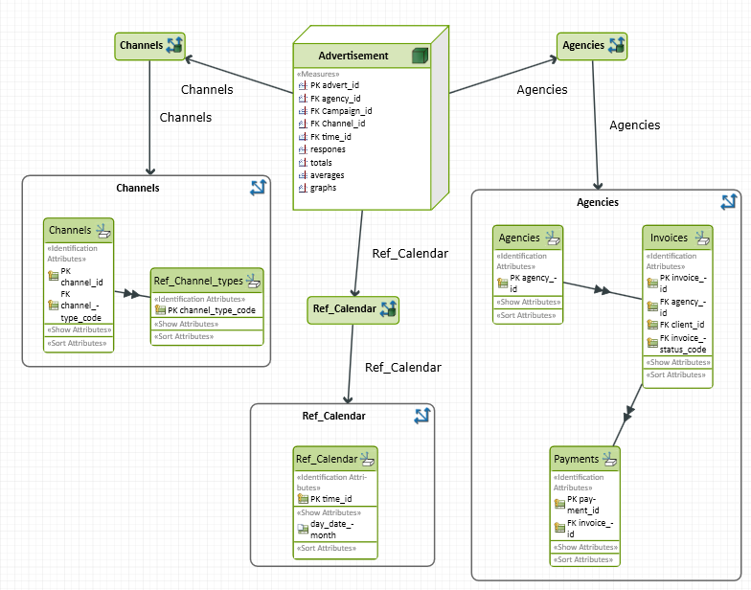

***Scenario 2: Amusement Parks***



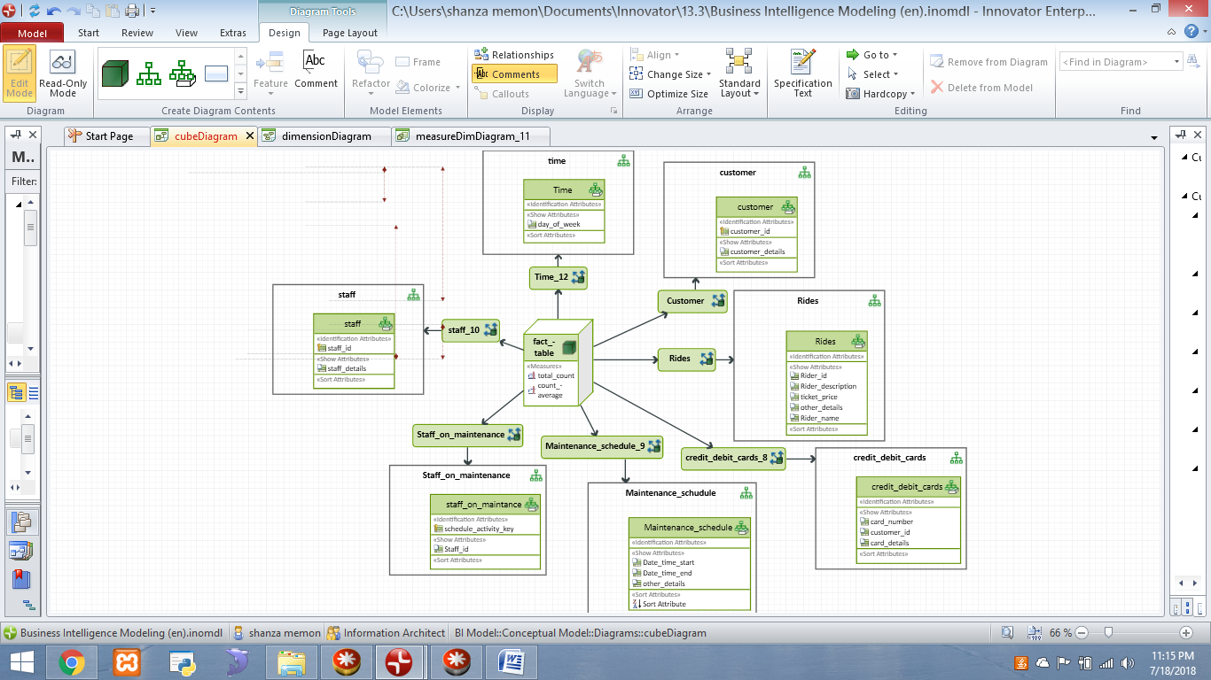

***Scenario 3: Clown registry***

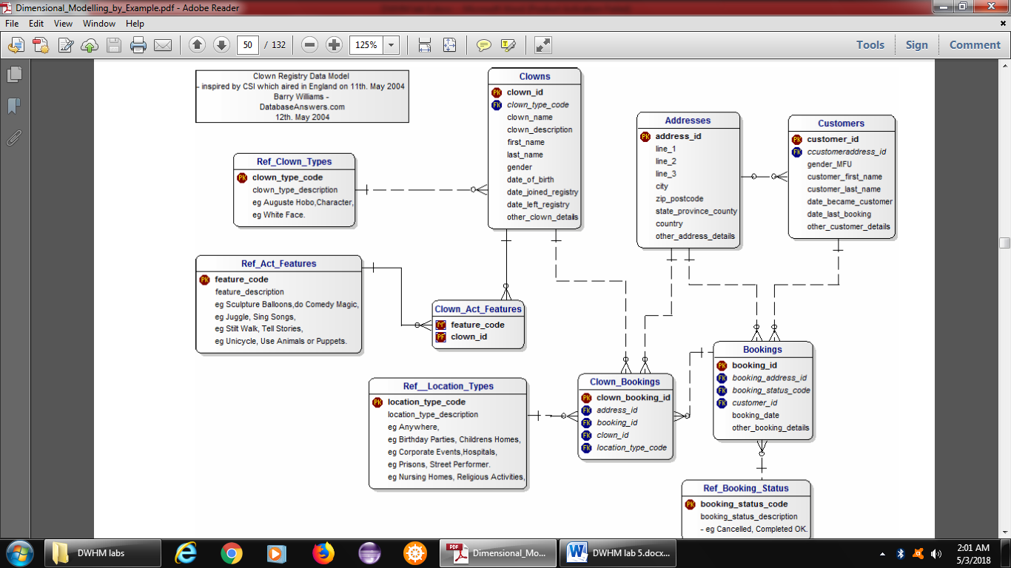

***Business Rules***

*1. People registered as Clowns are stored in the Clowns Table.*

*2. A Clown can have Acts with specific Features.*

*3. Clowns accept Bookings to perform at specific Locations for specific Customers.*

